1) Definir na área global a declaração do parameter:

*&---------------------------------------------------------------------*
*& Include MZDEVFORTOP *
*&---------------------------------------------------------------------*
PROGRAM sapmzdevfor MESSAGE-ID zwwm01.
* Campos gerais
DATA: ok_code LIKE sy-ucomm,
ws_code LIKE sy-ucomm,
ws_acao(10) TYPE c.

* Tables Control
CONTROLS: ws_tc9000 TYPE TABLEVIEW USING SCREEN 9000,
... (etc)

*$********************************************************************
*$*$* Lista de parâmetros - Tela 100
*$********************************************************************
SELECTION-SCREEN BEGIN OF SCREEN 100 AS WINDOW TITLE text-026..
SELECTION-SCREEN BEGIN OF BLOCK zb100 WITH FRAME TITLE text-027.
SELECTION-SCREEN SKIP 1.
SELECT-OPTIONS: s_lifnr FOR lfa1-lifnr,
s_lenum FOR zwwmugeori-lenum MATCHCODE OBJECT zmugeori,
s_matnr FOR zwwmugeori-matnr.
SELECTION-SCREEN SKIP 1.
SELECTION-SCREEN END OF BLOCK zb100.
SELECTION-SCREEN END OF SCREEN 100.
*

2) Definir um include para eventos da tela nnn (Parameter)

*----------------------------------------------------------------------*
* INCLUDE MZDEVFOREVT *
*----------------------------------------------------------------------*
AT SELECTION-SCREEN ON BLOCK zb100.

* PF-Status "%_CS" do programa "RSSYSTDB"
CHECK: sy-ucomm <> 'SPOS' AND "Gravar variante
sy-ucomm(2) <> '%0' AND "Seleção Múltipla
sy-xform <> '%_CONTROL_EXIT_DYNPRO'. "Cancelar slc.variante

* Chama rotinas para geração do processo de seleção
PERFORM verifica_fornecedor.
PERFORM obtem_registros_selecao.
PERFORM gera_tabela_selecao.

* Exibe tela para seleção de devolução ou sucateamento
CHECK NOT ti_selecao[] IS INITIAL.
LEAVE TO SCREEN 9000. "Chama 1ª tela do programa online

3) Na rotina de inconsistências (Envio de mensagem)
SELECT COUNT( * )
FROM lfa1
WHERE lifnr IN s_lifnr.
IF sy-subrc <> 0.
SET CURSOR FIELD 'S_LIFNR-LOW'.
MESSAGE e001 WITH text-025. <---- Exibe em popup (padrão default standard)
ENDIF.

OU

IF sy-subrc <> 0.
SET CURSOR FIELD 'S_LIFNR-LOW'.
MESSAGE S001 WITH text-025. <--- Barra de Status
LEAVE SCREEN.
ENDIF.

4) Definir a transação online para tela atribuida na
definição do parameter

Código de transação : ZDEVFOR
Cl.desenvolvimento : ZWBR
Texto da transação : Devolução a fornec.estoque bloqueado
Programa : SAPMZDEVFOR
Nº tela : 100

Selection Screens as Subscreens
The example shows how to include selection screens in subscreens.
Source Code
REPORT demo_sel_screen_as_subscreen.
SELECTION-SCREEN BEGIN OF SCREEN 1100 AS SUBSCREEN NESTING LEVEL 4.
SELECTION-SCREEN BEGIN OF BLOCK b1 WITH FRAME TITLE text-010.
PARAMETERS: p1(10) TYPE c,
p2(10) TYPE c,
p3(10) TYPE c.
SELECTION-SCREEN END OF BLOCK b1.
SELECTION-SCREEN END OF SCREEN 1100.
SELECTION-SCREEN BEGIN OF SCREEN 1200 AS SUBSCREEN NESTING LEVEL 4.
SELECTION-SCREEN BEGIN OF BLOCK b2 WITH FRAME TITLE text-020.
PARAMETERS: q1(10) TYPE c OBLIGATORY,
q2(10) TYPE c OBLIGATORY,
q3(10) TYPE c OBLIGATORY.
SELECTION-SCREEN END OF BLOCK b2.
SELECTION-SCREEN END OF SCREEN 1200.
DATA: ok_code TYPE sy-ucomm,
save_ok TYPE sy-ucomm.
DATA: number(4) TYPE n VALUE '1100'.
START-OF-SELECTION.
CALL SCREEN 100.
MODULE status_0100 OUTPUT.
SET PF-STATUS 'SCREEN_100'.
ENDMODULE.
MODULE cancel INPUT.
LEAVE PROGRAM.
ENDMODULE.
MODULE user_command_0100 INPUT.
save_ok = ok_code.
CLEAR ok_code.
CASE save_ok.
WHEN 'BUTTON1'.
number = 1100.
WHEN 'BUTTON2'.
number = 1200.
ENDCASE.
ENDMODULE.
AT SELECTION-SCREEN.
MESSAGE s888(sabapdemos) WITH text-030 sy-dynnr.
Description
Two selection screens, 1100 and 1200, are defined as subscreens. The static next screen number of screen 100 is 100. A subscreen area area and two pushbuttons with the function codes BUTTON1 and BUTTON2 have been created. The flow logic of screen 100 is as follows:
PROCESS BEFORE OUTPUT.
MODULE status_0100.
CALL SUBSCREEN area INCLUDING sy-repid number.
PROCESS AFTER INPUT.
MODULE cancel AT EXIT-COMMAND.
CALL SUBSCREEN area.
MODULE user_command_0100.
When the program is executed, the screen layout of screen 100 is displayed. There you see the selection screen 1100 as a subscreen. Using the pushbuttons of the main screen, you can switch between the two selection screens in the subscreen area. Before the system browses from selection screen 1200 to 1100, the required input fields must be filled. The input data is available to the program in the parameters at PAI.

*&---------------------------------------------------------------------*
*& Report ZLIXO2
*&
*&---------------------------------------------------------------------*
*&
*&
*&---------------------------------------------------------------------*

REPORT zlixo2.

TABLES: mara, marc.

DATA: entrada(30) TYPE c,
saida(20) TYPE c VALUE 'Robson o Grande!'.

DATA: ok_code TYPE sy-ucomm,
save_ok TYPE sy-ucomm.

DATA: nrtela(4) TYPE n,
vc_resposta.

DATA: lt_spopli TYPE STANDARD TABLE OF spopli
WITH HEADER LINE
INITIAL SIZE 8.

SELECTION-SCREEN BEGIN OF SCREEN 1100 AS SUBSCREEN NESTING LEVEL 4.
SELECTION-SCREEN END OF SCREEN 1100.

SELECTION-SCREEN BEGIN OF SCREEN 1101 AS SUBSCREEN NESTING LEVEL 4.
SELECT-OPTIONS: s1_mtart FOR mara-mtart.
SELECTION-SCREEN END OF SCREEN 1101.

SELECTION-SCREEN BEGIN OF SCREEN 1102 AS SUBSCREEN NESTING LEVEL 4.
SELECT-OPTIONS: s2_matkl FOR mara-matkl.
SELECTION-SCREEN END OF SCREEN 1102.

SELECTION-SCREEN BEGIN OF SCREEN 1103 AS SUBSCREEN NESTING LEVEL 4.
SELECT-OPTIONS: s3_mtart FOR mara-mtart.
SELECT-OPTIONS: s3_matkl FOR mara-matkl.
SELECTION-SCREEN END OF SCREEN 1103.

SELECTION-SCREEN BEGIN OF SCREEN 1104 AS SUBSCREEN NESTING LEVEL 4.
SELECT-OPTIONS: s4_werks FOR marc-werks.
SELECTION-SCREEN END OF SCREEN 1104.

SELECTION-SCREEN BEGIN OF SCREEN 1105 AS SUBSCREEN NESTING LEVEL 4.
SELECT-OPTIONS: s5_mtart FOR mara-mtart.
SELECT-OPTIONS: s5_werks FOR marc-werks.
SELECTION-SCREEN END OF SCREEN 1105.

SELECTION-SCREEN BEGIN OF SCREEN 1106 AS SUBSCREEN NESTING LEVEL 4.
SELECT-OPTIONS: s6_matkl FOR mara-matkl.
SELECT-OPTIONS: s6_werks FOR marc-werks.
SELECTION-SCREEN END OF SCREEN 1106.

SELECTION-SCREEN BEGIN OF SCREEN 1107 AS SUBSCREEN NESTING LEVEL 4.
SELECT-OPTIONS: s7_mtart FOR mara-mtart.
SELECT-OPTIONS: s7_matkl FOR mara-matkl.
SELECT-OPTIONS: s7_werks FOR marc-werks.
SELECTION-SCREEN END OF SCREEN 1107.

*TABLES: ekko, ekpo, mara.
*
*RANGES: r_matnr FOR mara-matnr OCCURS 0.
*DATA: t_txtlongo TYPE ytmmpesq_texto_longo,
* w_txtlongo TYPE yemmpesq_texto_longo,
* v_msgerr TYPE bapi_msg,
* v_selecao TYPE i.
*
*
*SELECTION-SCREEN BEGIN OF BLOCK b1 WITH FRAME TITLE text-t01.
*SKIP 1.
**SELECT-OPTIONS s_bukrs FOR ekko-bukrs.
*SELECT-OPTIONS:
* sc_mtart FOR mara-mtart.
** sc_ekorg FOR ekko-ekorg,
** sc_werks FOR ekpo-werks.
*PARAMETERS: p_texto TYPE atwrt OBLIGATORY.
*
*SELECTION-SCREEN END OF BLOCK b1.
*

*AT SELECTION-SCREEN ON VALUE-REQUEST FOR p_texto.
* PERFORM f4_busca_texto_longo.

START-OF-SELECTION.

CLEAR: vc_resposta.

lt_spopli-selflag = 'X'.
lt_spopli-varoption = 'Nenhuma opção'.
APPEND lt_spopli.

lt_spopli-selflag = space.
lt_spopli-varoption = 'Tp Material'.
APPEND lt_spopli.

lt_spopli-selflag = space.
lt_spopli-varoption = 'Grp Mercadoria'.
APPEND lt_spopli.

lt_spopli-selflag = space.
lt_spopli-varoption = 'Tp Material + Grp Mercadoria'.
APPEND lt_spopli.

lt_spopli-selflag = space.
lt_spopli-varoption = 'Centro'.
APPEND lt_spopli.

lt_spopli-selflag = space.
lt_spopli-varoption = 'Tp Material + Centro'.
APPEND lt_spopli.

lt_spopli-selflag = space.
lt_spopli-varoption = 'Tp Material + Grp Mercadoria'.
APPEND lt_spopli.

lt_spopli-selflag = space.
lt_spopli-varoption = 'Tp Material + Grp Mercadoria + Centro'.
APPEND lt_spopli.

CALL FUNCTION 'POPUP_TO_DECIDE_LIST'
EXPORTING
* CURSORLINE = 1
* MARK_FLAG = ' '
* MARK_MAX = 1
start_col = 5
start_row = 3
textline1 = 'Assinale a opção desejada:'
titel = 'SELECT-OPTION em Tela Online'
* DISPLAY_ONLY = ' '
IMPORTING
answer = vc_resposta
TABLES
t_spopli = lt_spopli
EXCEPTIONS
not_enough_answers = 1
too_much_answers = 2
too_much_marks = 3
OTHERS = 4.

CASE vc_resposta.
WHEN '1'.
nrtela = '1100'.
WHEN '2'.
nrtela = '1101'.
WHEN '3'.
nrtela = '1102'.
WHEN '4'.
nrtela = '1103'.
WHEN '5'.
nrtela = '1104'.
WHEN '6'.
nrtela = '1105'.
WHEN '7'.
nrtela = '1106'.
WHEN '8'.
nrtela = '1107'.
WHEN 'A'.
EXIT.
ENDCASE.

CALL SCREEN 100.

EXIT.

*--------------------------------------------------------
FORM f4_busca_texto_longo .
*--------------------------------------------------------
* DATA: l_vlrfld TYPE rkb1t_char,
* l_awrt TYPE atwrt.
*
** Obtem valor atua da tela
* CALL FUNCTION 'DYNPRO_STRING_READ'
* EXPORTING
* i_fieldname = 'P_TEXTO'
* i_repid = sy-repid
* IMPORTING
* e_string = l_vlrfld.
*
* l_awrt = l_vlrfld.
*
** Simula uma range para teste da função
** REFRESH: r_matnr.
** r_matnr-sign = 'I'.
** r_matnr-option = 'BT'.
** r_matnr-low = '000000000000000001'.
** r_matnr-high = '99999999999999999'.
** APPEND r_matnr.
*
*
** Chama rotina de pesquisa
* CALL FUNCTION 'Y_MM_PESQ_TEXTO_LONGO'
* EXPORTING
** PI_MATNR_RANGE =
** PI_WERKS_RANGE =
** PI_MATKL_RANGE =
* pi_mtart_range = sc_mtart[]
* pi_atwrt_search = l_awrt
** PI_SHOW_SEARCH = 'X'
** PI_NRMAX_SEARCH = 500
* pi_line_screen = 3
* pi_col_screen = 52
* pi_opcao_mm01 = 'X'
* IMPORTING
* pe_msgerr = v_msgerr
* pe_indx_slc = v_selecao
* TABLES
* pt_textolongo = t_txtlongo.
*
*
*
** Atualiza campo de seleção
* CHECK: v_selecao > 0.
*
* READ TABLE t_txtlongo INDEX v_selecao INTO w_txtlongo.
* p_texto = w_txtlongo-matnr.

ENDFORM. "f4_busca_texto_longo
*&---------------------------------------------------------------------*
*& Module user_command_0100 INPUT
*&---------------------------------------------------------------------*
* text
*----------------------------------------------------------------------*
MODULE user_command_0100 INPUT.

BREAK-POINT.

LEAVE.

ENDMODULE. " user_command_0100 INPUT

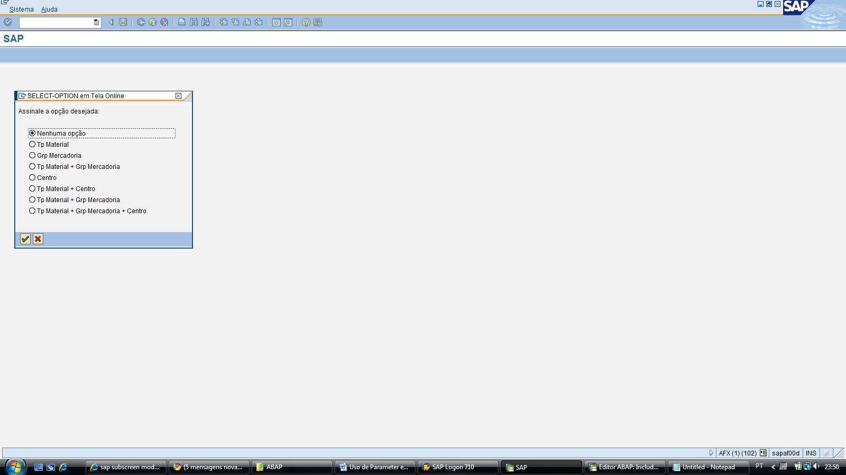

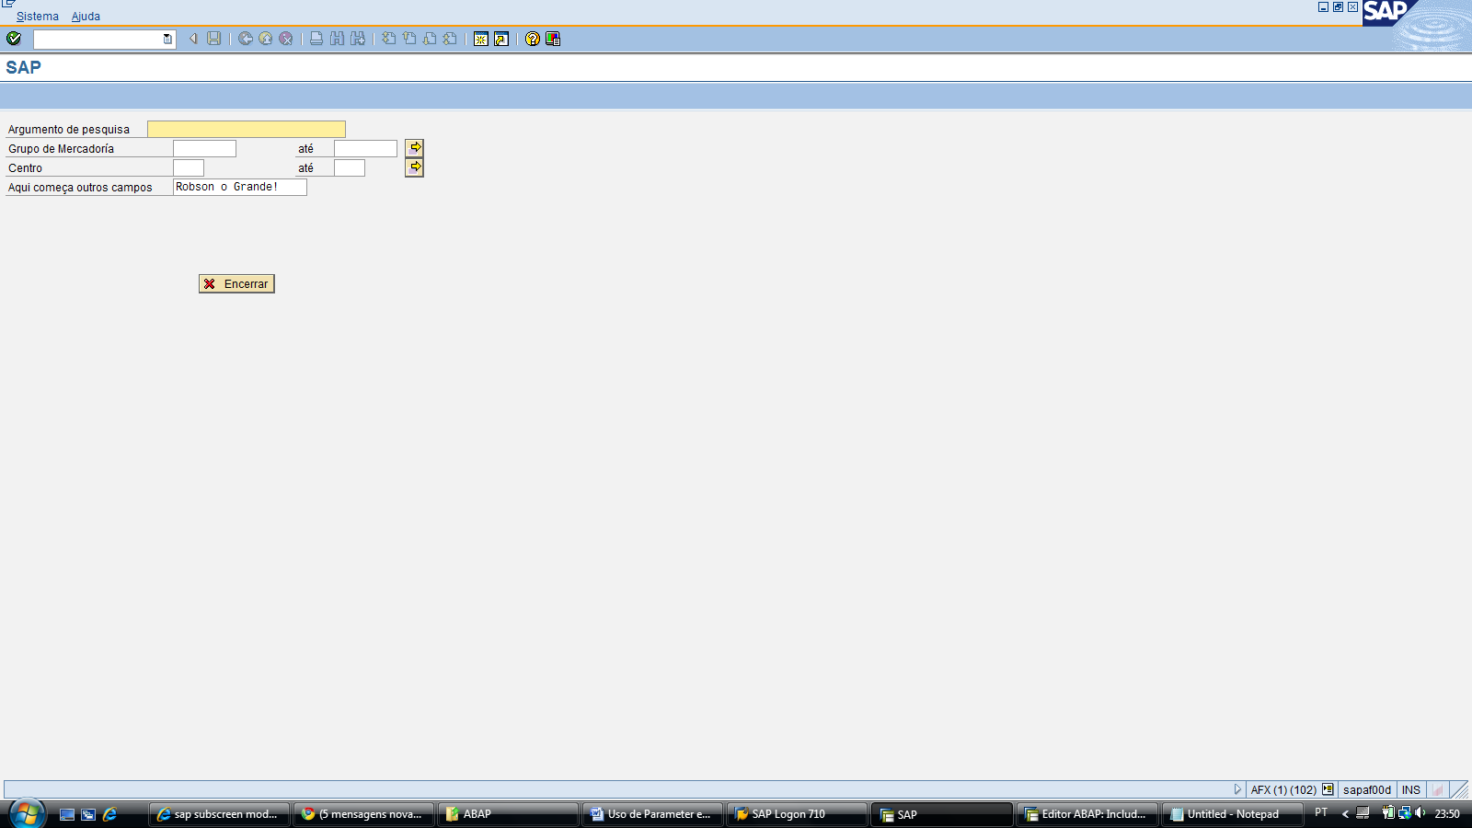

PROCESS BEFORE OUTPUT.
* MODULE STATUS_0100.
*
CALL SUBSCREEN area INCLUDING sy-repid nrtela.

PROCESS AFTER INPUT.

CALL SUBSCREEN area.
MODULE user_command_0100.

